**Project Design Phase**

**Problem – Solution Fit Template**

|  |  |
| --- | --- |
| Date | 26 June 2025 |
| Team ID | LTVIP2025TMID36168 |
| Project Name | HealthAI: Intelligent Healthcare Assistant Using IBM Granite |
| Maximum Marks | 2 Marks |

**Problem – Solution Fit Template:**

To solve complex health-related challenges in a way that aligns naturally with users' behaviors, boosting adoption, satisfaction, and trust. The Problem-Solution Fit simply means that you have found a problem with your customer and that the solution you have realized for it actually solves the customer’s problem. It helps entrepreneurs, marketers and corporate innovators identify behavioral patterns and recognize what would work and why

**Purpose:**

* Solve complex health challenges in alignment with user behaviors
* Increase adoption through leveraging familiar interaction channels
* Sharpen communication and marketing with the right triggers
* Increase touch‑points and build user trust by addressing frequent needs
* Ground improvements by understanding the user’s current situation

**Template:**

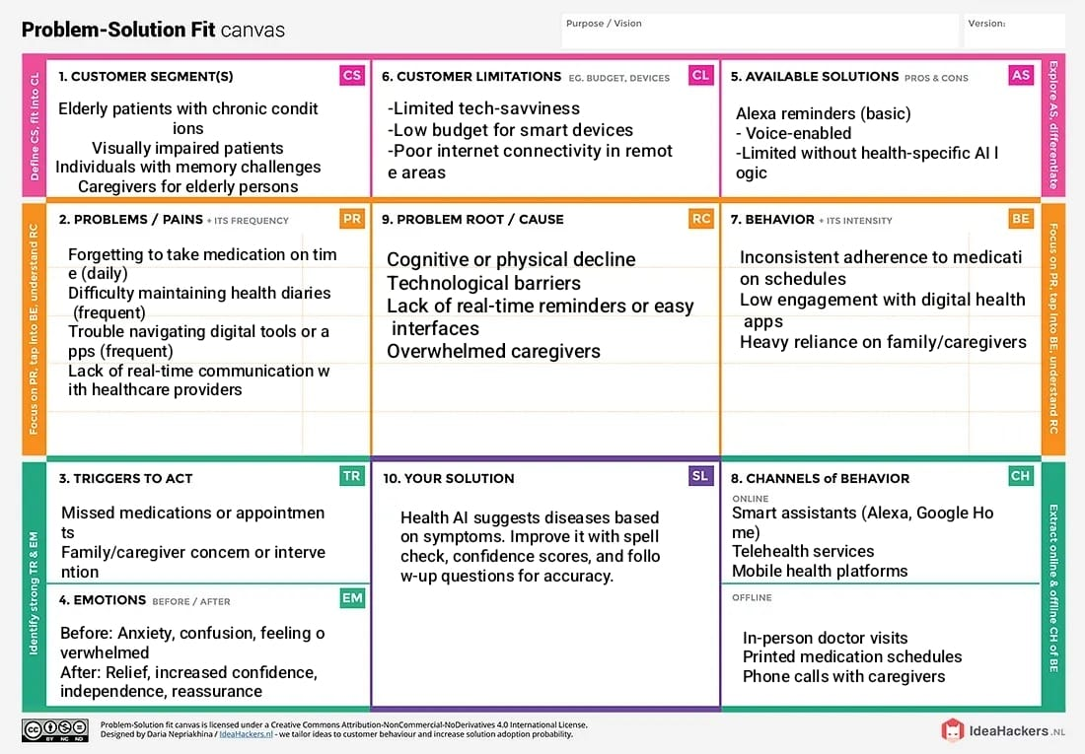

References:

1. <https://www.ideahackers.network/problem-solution-fit-canvas/>
2. <https://medium.com/@epicantus/problem-solution-fit-canvas-aa3dd59cb4fe>